How to use db migration to manage database.

Please follow these steps below:
1. Create two models:

+ User

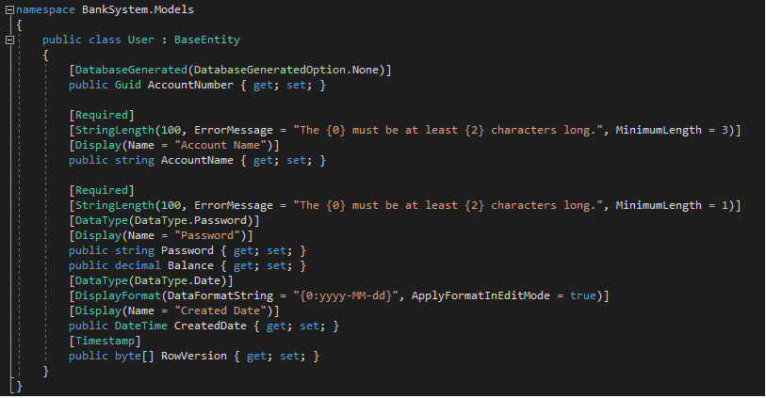

+ Transaction
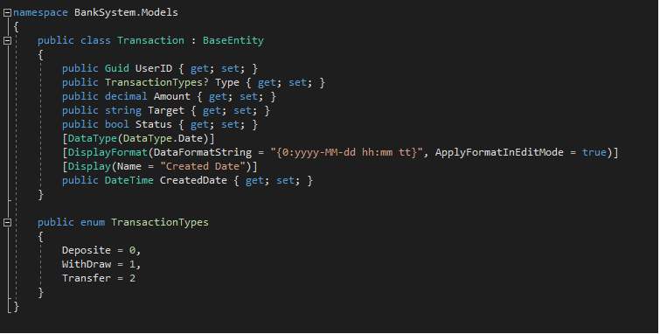

2. Create class BankSystemContext
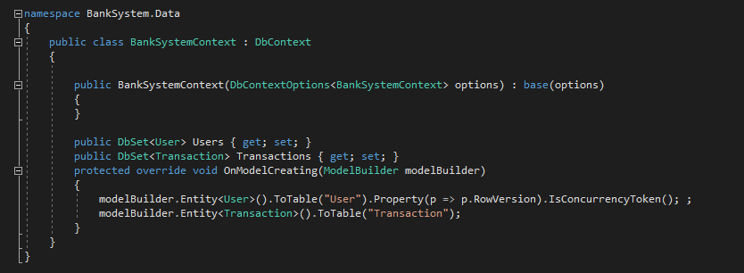

3. Create class DbInitializer
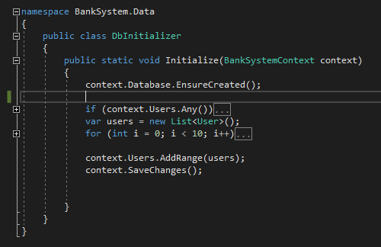

4. Init for BankSystemContext, DbInitializer in class Startup.cs

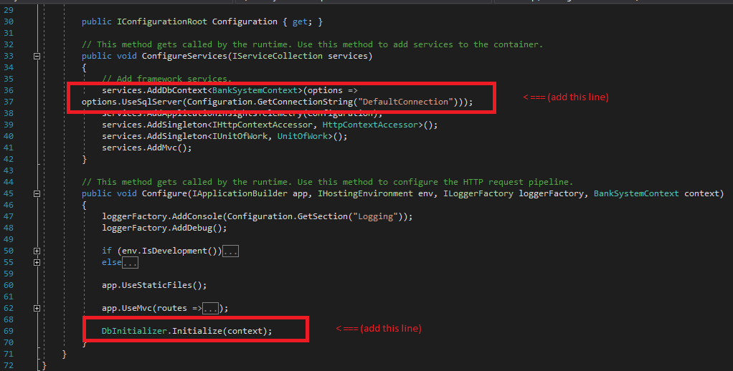

5. Build and run project

6. Result

